Exercise 5: IPv6 in packet tracer

Topology
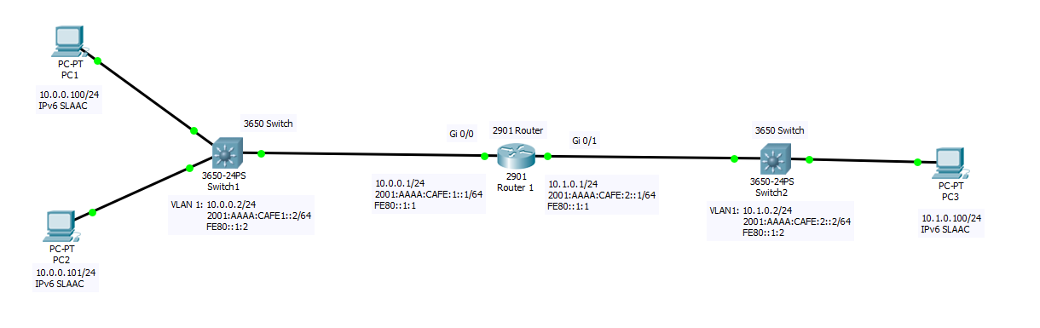

In this assignment we will build an IPv6 network. Build the topology in packet tracer using a 2901 Router and a 3650 Switch. To power on the switch, you will have to add a power supply to the switch. Drag the power supply into the power supply slot of the switch.
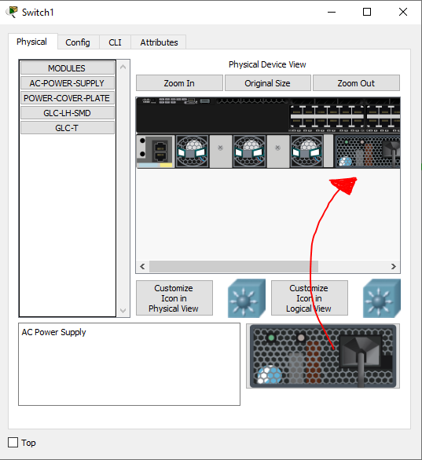
Computers, routers and many other network devices can run a dual stack. Which means they get assigned both an IPv4 and an IPv6 address. And they can communicate with each other over both networks, using either the IPv4 or IPv6 addresses.

Configuring the IPv4 network

Configure the router
We have done this in a previous assignment. You can use this part to refresh and test your memory.

- Set the hostname of the router to Router1
- Set the enable password to “cisco” and the console password to “student”
- Configure the IPv4 address of both interfaces. Use the CLI commands!
- Enable telnet on the router
- Save configuration

Configure the switches
We have done this in a previous assignment. You can use this part to refresh and test your memory.
- Set the hostnames of the switches to Switch1 and Switch2
- Set the enable password to “cisco” and the console password to “student”
- Configure the IPv4 address of vlan 1. Use the CLI commands!
- Enable telnet on the switches
- Save configuration

Configure the computers
We have done this in a previous assignment. You can use this part to refresh and test your memory.
- Set the IPv4 address of the computers
- You should be able to ping from PC1 to PC2 and PC3, from PC1 and PC2 to Switch1 and Router1, from PC3 to Switch2 and Router1. You will not be able to ping from PC1 or PC2 to Switch2 or from PC3 to Swich1.
  - Why?
No default gateway is set on the switch. The switch cannot send a reply to a remote network
- You should be able to telnet into the Router from all computers, Switch1 from PC1 and PC2 and Switch2 from PC3.
Your IPv4 network is now up and running!

Configuring IPv6 network

- Enter the following command to enable IPv6 on the router. This will instruct the router to send router advertisement packets on the network.
    - Router1(config)#ipv6 unicast-routing
      - IPv4 routing is enabled by default on cisco routers, IPv6 routing is disabled by default on cisco routers.
- Assigning an IPv6 address to an interface is very similar to IPv4. Assign the Global Unicast IPv6 Addresses to both the interfaces using the following command
    - Router1(config)#interface gi 0/0
    - Router1(config-if)#ipv6 address 2001:AAAA:CAFE:1::1/64
  - What is the full IPv6 address of this router?
2001:AAAA:CAFE:0001:0000:0000:0000:0001/64
- You can verify the IPv6 address using the following commands
    - Router1#show ipv6 int brief
    - Router1#show ipv6 int gi 0/0
  - Why are there 2 unicast addresses assigned to this interface?
Link local and Global unicast
  - What kind of IP addresses are these (2001, FE80) and how can you recognize them?
Link local and Global unicast
  - What are they used for?
Link local only on local network, not routed
Global unicast for remote networks and internet
  - Which multicast addresses are the router interfaces listening to?
FF02::1, FF02::2, 2 solicited Nodes
  - What kind of multicast addresses are these?
All devices on network, All routers on network, solicited node
- Open the command prompt of PC1 and show the ip addresses using the ipconfig command.
  - Is there an IPv6 address assigned to the interface?
FE80:
  - What kind of IP address is this?
Link local
Network devices self-generate a Link-Local IPv6 Address. This address can be used to communicate on the local subnet.
- Try to ping from PC1 to the link-local Address of the Gi 0/0 interface of the router.
  - Where the pings successful?
Yes
- Try to ping from PC1 to the link-local Address of the Gi 0/1 interface of the router.
  - Where the pings successful? Why not?
Link local is not routed, only for local network

The link-local address can be assigned statically as well. This is common for routers, switches and servers.
- Using the following command, you can statically configure the link-local address of a router interface
    - Router1(config-if)#ipv6 address FE80::1:1 link-local
- Verify the ip address and the multicast groups using the show commands.
  - Did any of the multicast addresses change? Which one? Why?
Solicited node of link local
- You should be able to ping from PC1 to the statically assigned link-local address of the router.
- You should be able to ping from PC1 to PC2 using the link-local address of PC2
- Try to ping from PC1 to the link-local address of PC3
  - Where the pings successful?
  - Why not?
PC3 on remote network
- Open the CLI of Router1 and ping to the link local address of PC1
  - Why does the router ask for an interface on which the pings should be send?
Link local range is the same for both network interfaces
      - Use the full name of the interface without spaces (GigabitEthernet0/0)
- The following command in Router1s CLI will show the IPv6 routing table
    - Router1#show ipv6 route
      - You can see that this routing table is very similar to the IPv4 routing table. Because no dynamic routing protocols or static routes are configured, only the directly connected networks show up in this routing table. But similar to IPv4, you can add static routes to remote IPv6 networks.
      - It is important to notice that only Global Unicast addresses show up in this table. Link local addresses do not show up in the routing table. These addresses are not routable! This is why you have to specify the Output interface when you want to ping a link local ip address from a router.

Configure the global unicast address
By enabling IPv6 unicast-routing, routers send router advertisement packets on the network, either periodically or in response of a router solicitation packet send by a client. A clients on the network can use the router advertisement packets to obtain their own global unicast address.
- Enter simulation mode in packet tracer. Disable all filters except ICMPv6 and NDP (Network Discovery Protocol in IPv6).
- Enable IPv6 auto configuration on PC1
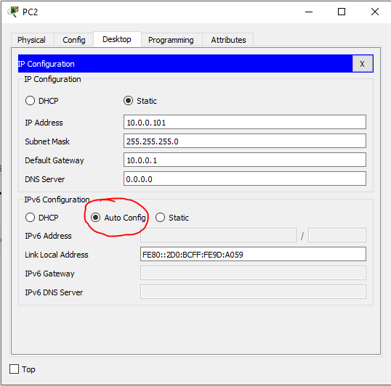

- A packet is generated and send from PC1 to Router1. This is a Router Solicitation by PC1 to obtain the network information.
  - What is the source IP address of this packet? What kind of IP address is this?
FE80:… link local
  - What is the destination IP address of this packet? Which devices are listening to this address?
FF02::2 All routers multicast
      - MLD snooping is not enabled on the switch. MLD snooping is needed for the switch in order to filter multicast packets. Because this is not enabled, the switch will not filter multicasts but just send the multicast to all ports. Enabling MLD snooping is not possible in packet tracer and beyond the scope of this course.
- The router sends a router advertisement in response.
  - What is the source IP address of this packet?
FE80:… link local
      - This IP address is used by the host as the default gateway.
  - What is de destination IP address of this packet? Who is listening to this address?
FF02::1 all devices multicast
- In the “outbound PDU Details” you can find the content of this packet.
  - What is the prefix send in this packet?
2001:AAAA:CAFE:1
  - What is the prefix length send in this packet?
64
  - What is the Maximum Transfer Unit (MTU) send in this packet? This is the maximum size of the packets send on the link.
1500
  - What is the Link Layer Address send in this packet?
MAC of the router
      - The MAC address of the router is send in this router advertisement packet. Hereby, the hosts on the network have the MAC address of the default gateway. Therefor host don’t need to send additional packets to obtain the MAC address of the default gateway.
- Switch back to real time mode in packet tracer.
  - Which IP address did PC1 generate? You can find the ipv6 address information using the command ipv6config in a command prompt. This does not work on a real windows computer. On a real computer, the command ipconfig will show the IPv4 and IPv6 address information.
2001:AAAA:CAFE:1: <- with MAC address and FFFE in the middle

  - What is the prefix of this IP address?
2001:AAAA:CAFE:1
  - What is the Interface ID of this IP address? And how is this interface ID generated?
MAC address with FFFE in the middle and one bit flipped
- Enable the autoconfiguration on PC2 and PC3.
- You should be able to ping from PC1 to PC3 on the remote network, using the Global Unicast Address of PC3.

- Enter the simulation mode of packet tracer. Make sure only the ICMPv6 and NDP protocols are selected in IPv6.
- Ping from PC1 to the global unicast IPv6 address of PC2. A neighbor solicitation packet is generated by PC1 to find the MAC address of the device with this IP address
  - What is the destination address of this packet?
Solicited node multicast generated from the global unicast IPv6 address of PC2
  - What kind of address is this?
Solicited node multicast
- Capture forward 3 times. A neighbor advertisement packet is generated by PC2.
  - What information is in the link layer option in the “outbound pdu details” tab of this packet?
MAC address of pc2
  - What is the source and destination IP address?
  - What kind of addresses are these?
Global unicast addresses
- Capture forward 2 times. The MAC address of PC2 is added to the neighbors cache (similar to the ARP cache in IPv4). You can see that the ICMPv6 Echo request can be send using the MAC address from the neighbor advertisement packet.
- Enter the real time mode in packet tracer and you should see the replies in the command prompt of PC1.

Extra
Use wireshark to examine IPv6 traffic
On your computer, use the ipconfig (Windows) or ifconfig (linux, mac) to see if your computer has a Global Unicast Address. If you have one, you can do this exercise.
Disconnect your computer from the internet. Open Wireshark and start monitoring. Reconnect your computer to the internet.
- Can you find the following information
  - Router solicitation with FE80::2 multicast address as destination
  - Router advertisement with Prefix, prefix length
  - Neighbor sollicitation
  - Neighbor advertisement
  - Multicast listener report

- Use the command “ping -6 www.google.be” in a command prompt to force a ping using the ipv6 network.

- To use nslookup for ipv6 enter the following commands

    - C:\nslookup
    - >set q=AAAA
    - www.google.be

- To show the neighbors cache, you can use the netsh command
    - C:\netsh
    - netsh>interface ipv6
    - netsh interface ipv6>show neighbors

